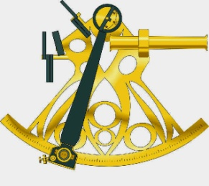
COOK ISLANDS MARITIME TRAINING CENTRE

Boatmaster Course

APPLICATION/ENROLMENT FORM

Date ……………………..
First name ………………… Last (Family) name ………………………
Name by which you wish to be called for the Course…………………….
Date of Birth ……/……/…… Nationality…………………………
(dd/mm/yy)

Tel. No., Work……………… Home…………… Mobile……………..
Email: .........................................................................
Education level ……………………………….
Present Employment…………………………………..
What sort of boat do you have, or operate, if any? (State length and engine type)
……………………………………………………………………………………………………………………………………………………………………………………
Where do you intend to operate? Lagoon Open water
Give details of any relevant Certificates you may have, or Workshops or Courses you have attended.(Radio Operator, First Aid, Day Sailor, etc.)
…………………………………………………………………………………………………………………………………………………………………………………………………………………………………………………………………………………………………………………………………………………………………………

